Requirements

How and why did you select the tools , plateform

Disaster area – shiyachin , Ladakh , jammu kasmir , uttrapkahnd , Arunachal pradhesh , assam

**Smart sheltering :**

**Smart Sheltering** project is designed to address challenges in disaster management and refugee care. It uses IoT-based technologies to improve the safety, security, and efficiency of shelters in disaster-stricken areas.

Key objective :

1. **Efficient Resource Management**: Automate the allocation and tracking of essential resources such as food, water, and medical supplies.
2. **Real-time Monitoring**: Use smart sensors to monitor environmental conditions, crowd density, and the safety of the shelter.
3. **Enhanced Communication**: Establish a seamless communication system between shelter occupants and management authorities.
4. **Emergency Response**: Provide early warning systems and mechanisms for evacuation during secondary disasters.
5. **Solar heated**

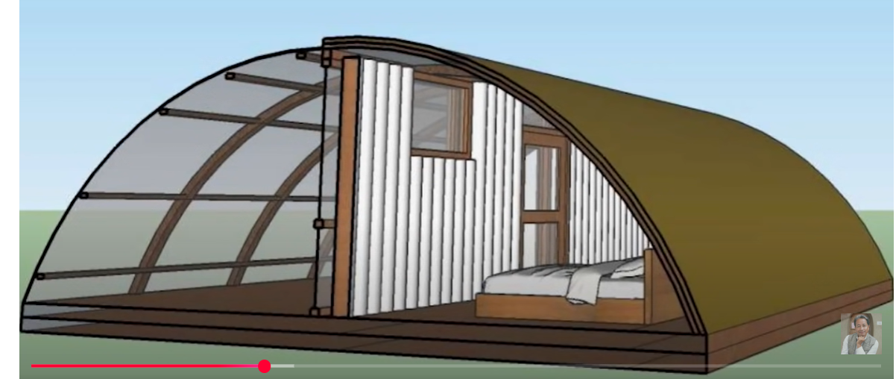

There are two chamber heat absorb chamber and other is sleeping chamber

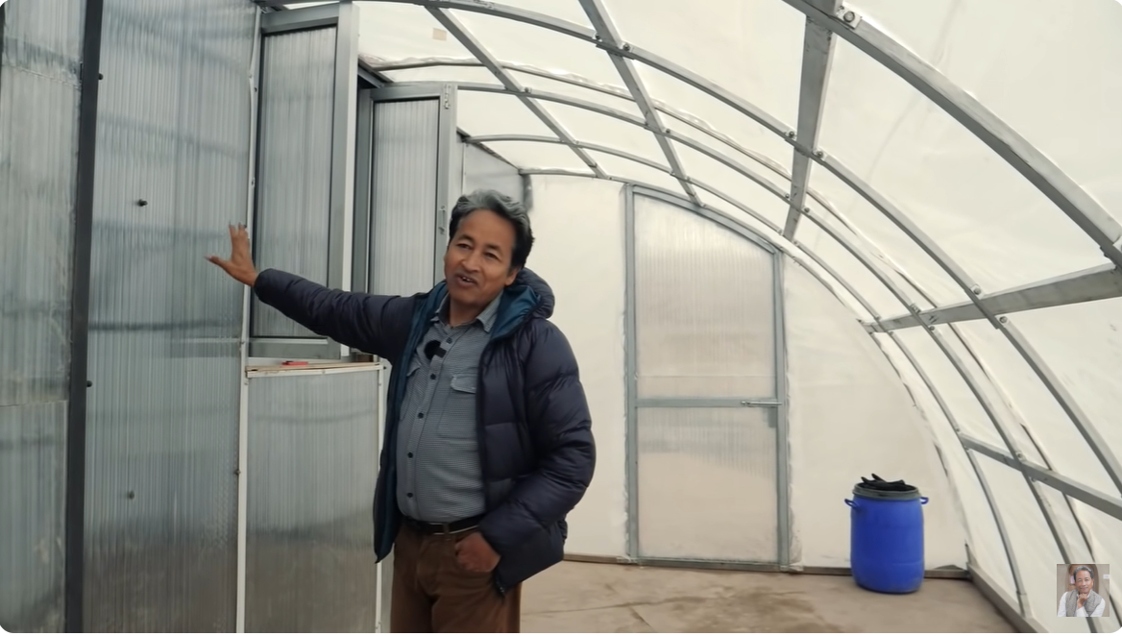

Heat bank

Polycarbonate layer- heat ander aaajye but bahar naa aye

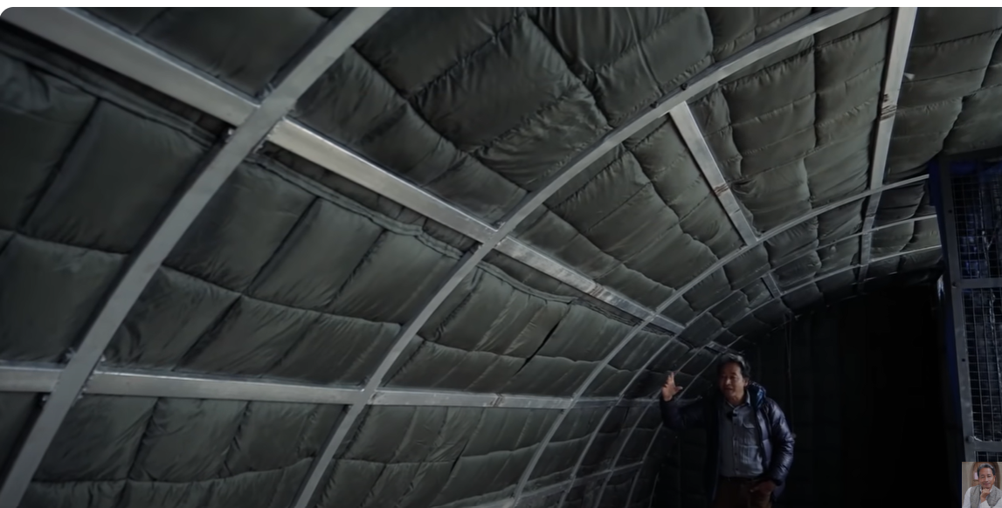

Tent ka shape circular has surface area less hai jiske karan heat bahar bahut minute jaate hai

Technologyes: temperature sensor – dht11

Pluse sensor

**Auto rover or line following robot :**

Tt gear motor , 4 wheels , motor driver , , Arduino , 2 ir sensor : infrared sensor

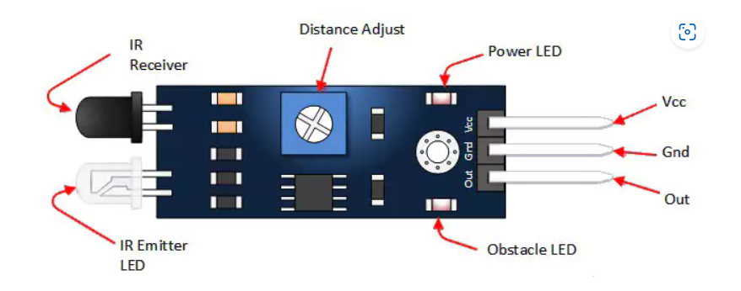

Black surface – absorb light and white surface – reflect surface 3

<https://youtu.be/s8NNQoUzy54?si=s0wGE3aZMIetft4U>

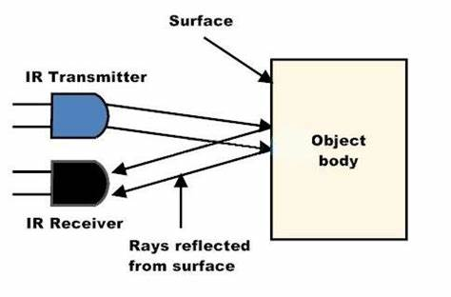

**Iot based vehicle accident detection system :**

Notification system , anti sleep alarem , alcohol , smoke detection

Sensors:

Acceloremeter -> ADXL335

, gps sensor , gsm module

Ir sensor , -> USE infrared rediation

ULTRASONIC SENSOR- USE SOUND WAVE FOR MEANSURE DISTNACE

Motor driver L298N: for amplify current

**Automated Facial Recognition-Based Attendance Tracking and Management System Utilizing OpenCV:**

Numpy – data add in array

, dlib- facila landmark detection

, opencv – wornk on image and vedio

, face-recognition – fac edetect

**q- which face detection algorithm I use**

sol: HOG (Histogram of Oriented Gradients)-based face detection,